ลง flutter บน Windows 10

# Follow by step in <https://medium.com/@quicky316/install-flutter-sdk-on-windows-without-android-studio-102fdf567ce4> Install Flutter SDK on windows without Android Studio

[](https://medium.com/@quicky316?source=post_page-----102fdf567ce4----------------------)

[Majed Ali](https://medium.com/@quicky316?source=post_page-----102fdf567ce4----------------------)

Follow

[Jan 22](https://medium.com/@quicky316/install-flutter-sdk-on-windows-without-android-studio-102fdf567ce4?source=post_page-----102fdf567ce4----------------------) · 3 min read

Let me free !

To me Android Studio just a nightmare, as soon as I start it, and my PC start screaming endlessly, so I started a journey to find a way to install Flutter SDK without using or installing Android Studio, hence the following lesson come into existence.

All the commands in this tutorials are executed using windows command prompt, just run it from start menu, or hit <windows-key> + R then type cmd

# Create the working Dir

To keep everything in single place we will consider the dir C:\Android as main working directory

cd C:\  
mkdir Android  
cd Android

# Installing OpenJDK 8

Download Windows binaries from the following url:  
<https://github.com/AdoptOpenJDK/openjdk8-binaries/releases/download/jdk8u202-b08/OpenJDK8U-jdk_x64_windows_hotspot_8u202b08.zip>

## Other releases:

<https://github.com/AdoptOpenJDK/openjdk8-binaries/releases>

extract it and rename the internal folder “jdk8u202-b08” to “openjdk” and copy it under “C:\Android” folder, so its path will be:

C:\Android\openjdk

# Installing Flutter SDK

Download flutter sdk latest version from following url:  
<https://flutter.io/docs/get-started/install/windows>  
extract it, and copy the folder with the name “flutter” to C:\Android folder, so the full path will be:

C:\Android\flutter

# Installing Android command tools

Download Windows version of Android command tools from the following url:  
<https://developer.android.com/studio/#command-tools>  
extract it and rename the “tools” folder to “sdk”, then copy it under C:\Android folder, so the full path will be:

C:\Android\sdk

# Set Some Environment variables

We need to define some environment variable which let the above tools know how to contact each other, form command prompt run these commands, one by one:

setx JAVA_HOME “C:\Android\openjdk”  
setx ANDROID_HOME “C:\Android”  
setx ANDROID_SDK_ROOT “C:\Android\sdk”  
setx path “%path%;”C:\Android\sdk;C:\Android\sdk\bin;C:\Android\flutter\bin”

# Download Android SDK

As you may already know the Flutter are based on Android SDK to work , so we need to download system images, platform tools, build tools, platforms, and emulator, by running the following commands:

sdkmanager “system-images;android-27;default;x86_64”  
sdkmanager “platform-tools”  
sdkmanager “build-tools;27.0.3”  
sdkmanager “platforms;android-27”  
sdkmanager emulator

***Note1:****the date I write this tutorials the latest version of the above images was 28, but I downloaded the previous one, so I can develop app for wider range of Android OS versions, you can run the command*sdkmanager --list*to see available images and choose whatever you want.*

***Note2:****Make sure to accept any license that appear by pressing*y*then*Enter*, or nothing will be downloaded.*

# Accept the licenses

Android sdk images have licenses that need to be accepted, you do that with the command:

sdkmanager — -licenses

just press y then Enter for for every license.

# Configure Flutter

configure flutter to know the dir of Android sdk path

flutter config — -android-sdk C:\Android\

# Create the Emulator

Create a new emulator with the name “nexus” or choose the name you want:

avdmanager -s create avd -n nexus -k “system-images;android-27;default;x86_64”

*answer with [no] to the showed question.*

# Run the emulator

flutter emulators --launch nexus

# Moment of truth

flutter doctor -v

*This command should give all green and ok, ignore the Android Studio complain, since this lesson is all about ignoring it in the first place.*

# Test flutter code

cd C:\Android\flutter\examples\hello_world  
flutter run

# [Extra] Other Good Emulator commands

Run emulator using emulator command, it should be executed from inside C:\Android\emulator

cd C:\Android\emulator  
emulator -avd nexus

This command is good to see error messages

## Create an emulator based on real device features

avdmanager -s create avd -n latest -k “system-images;android-27;default;x86_64” -d 30

*you need to change the 30 with any other device id, you can see all available devices with the command:*

avdmanager list device

## Delete existed virtual emulator

avdmanager delete avd -n nexus

## List all already created virtual emulators

avdmanager list avd

## for more help

avdmanager help

1. $ git clone -b dev <https://github.com/flutter/flutter.git>
2. set User variables

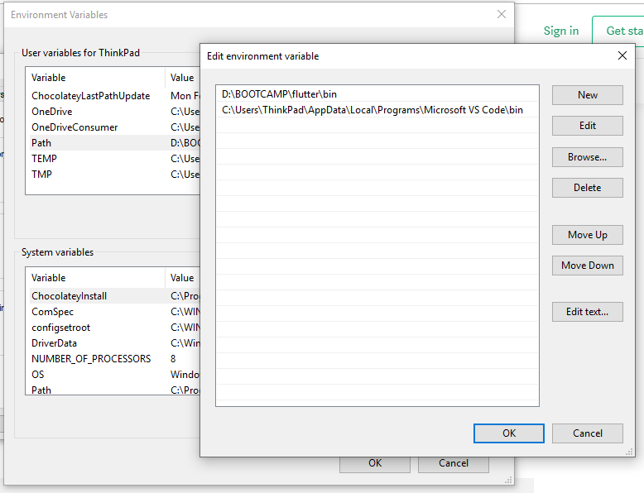

1. $ flutter docter
2. $ npm install -g expo-cli
3. Set Env Variable %USERPROFILE%\AppData\Roaming\npm

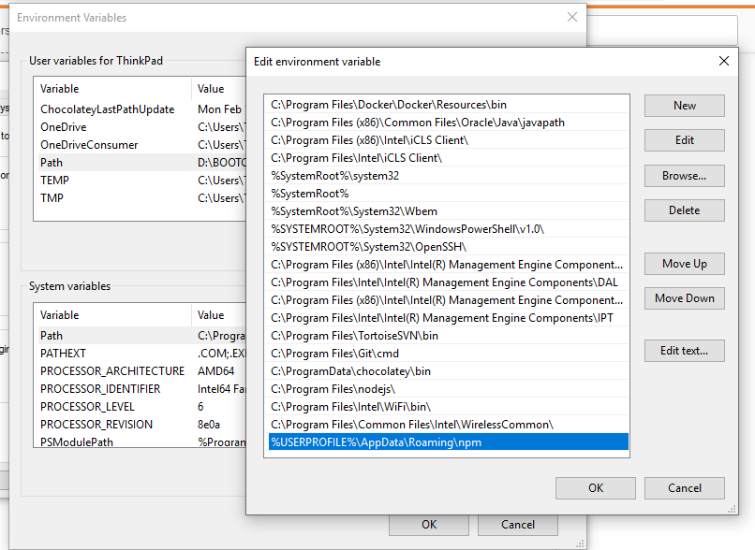

1. $ expo –version
2. 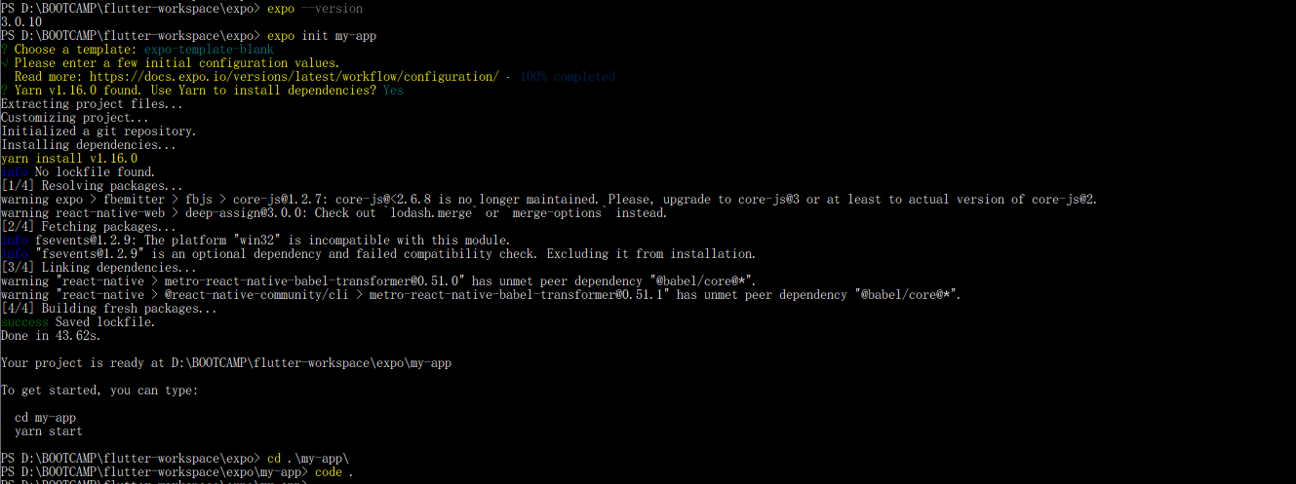
3. In VS Code (install extension Dart, Flutter)

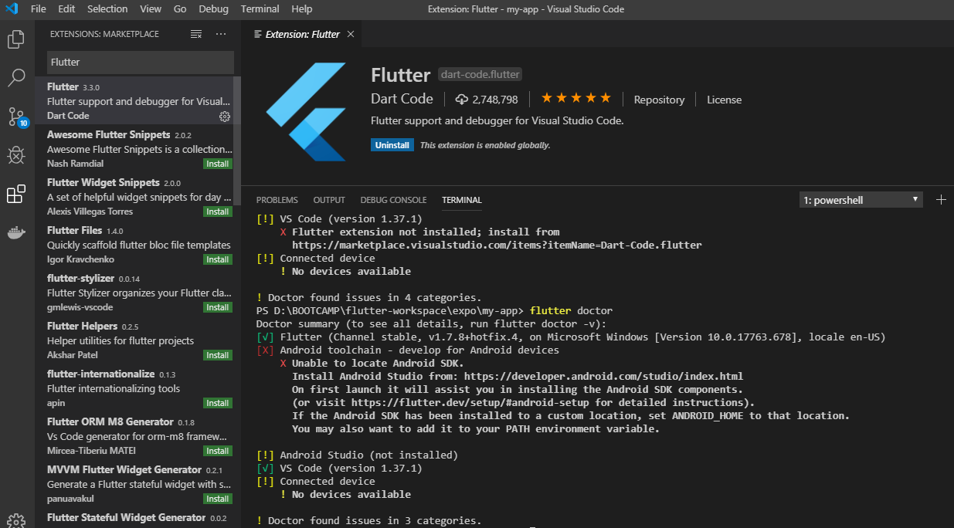

1. Install Android SDK and plugin flutter
2. $ flutter devices
3. $ flutter doctor
4. $ flutter emulators